1. What reference type obligatory needs a ReferenceQueue in its constructor?

* Final
* Soft
* Weak
* **Phantom**

1. Can you recognize design pattern by its UML diagram?

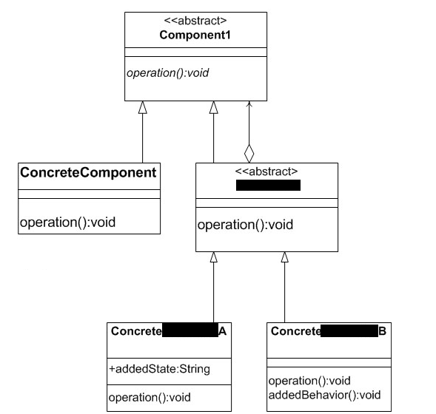

* template method
* **decorator**
* composite
* bridge

1. Which design pattern should you use when …

*You want to avoid permanent binding between an abstraction and its implementation. This might be the case for example, when the implementation must be selected or switched at run-time.*

* Abstract Factory
* Strategy
* **Bridge**
* Template Method

1. How can Component in composite pattern be implemented in Java?

* Abstract class
* Interface
* Concrete class
* **All of above**

1. Design pattern that add responsibilities to objects dynamically is?

* **Decorator**
* Bridge
* Composite
* Command

1. When adding of functionality happens in Decorators?

*Decorators change the behavior of their components by adding new functionality to the component. When this adding of the functionality can happen?*

* only before method calls
* only after method calls
* Decorator does not add new functionality to the component
* **before, after and in place of method calls**